My Assessment Plan
During this course, you’ll use this document as a guide to create and reflect on your personal assessment plan. This includes three parts.
Part 1 – Selecting Appropriate Assessment Tools for Your Learning Objectives
You’ll identify a learning objective (something your students should know or be able to do) and an assessment that is align to help measure and evaluate student achievement on this learning objective. You can choose a learning objective that is be best aligned with a traditional assessment or performance based assessment.
Part 2 – Making Improvements to your Assessment Tool
You’ll get an opportunity to examine and make improvements to your assessment tools. If you chose a traditional assessment in part 1, you’ll explore ways you can avoid common problems with questions you are asking students. If you chose a performance assessment in part 2, you’ll create good descriptors on a scoring rubric to articulate the levels of performance for an identified criteria.
Part 3 – Providing Wise Feed
You’ll get an opportunity to practice providing constructive feedback that helps students know what they do and do not understand, as well as encouraging them to learn from their errors.

Figure 1 shows a concept map that describes the inter-connections to several assessment terms.
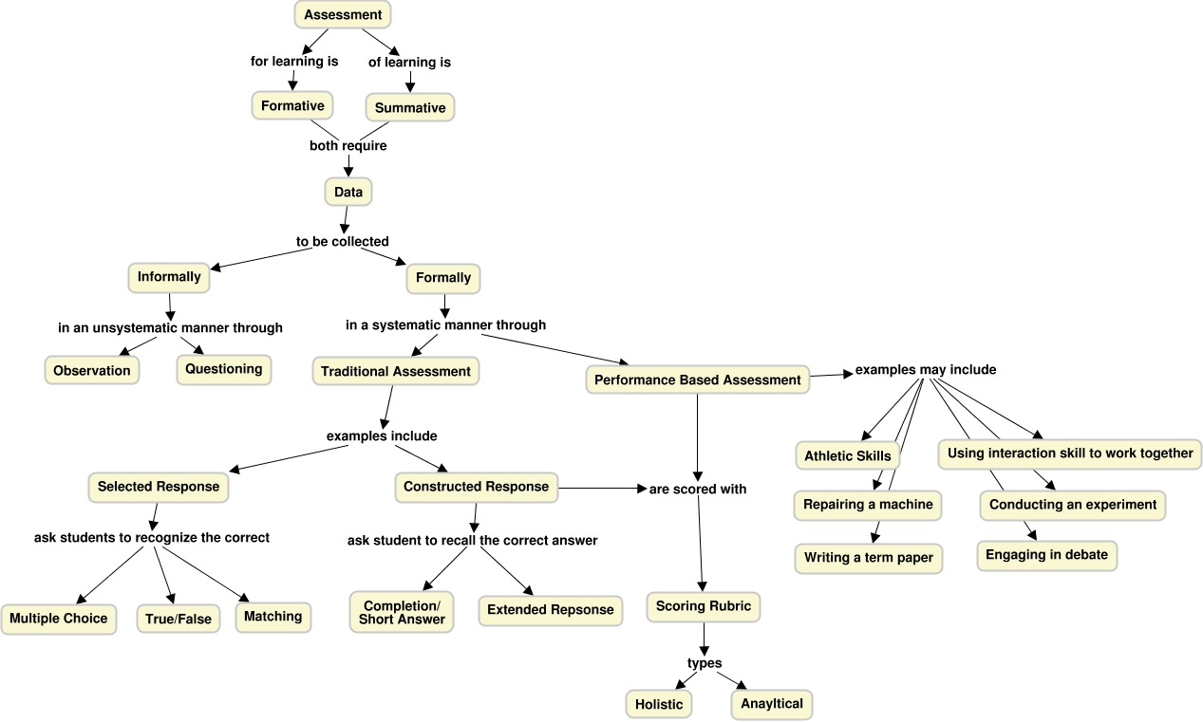
Figure 1 - Assessment Concept Map

Table of Contents
About Assessment 2
About Learning Objectives: What should my students know or be able to do? 2
Writing Effective learning objectives 3
Part 1: Assessment Types 4
Traditional Assessments 4
Performance Based Assessments 4
Part 1 Practice – Aligning Your Assessment 5
Option 1A - A traditional assessment tool 5
Option 1B - A performance based assessment tool 5
Part 2: Measurement and Evaluation 6
Scoring Traditional Assessments 6
Points and Scoring Rubrics 6
Part 2 Practice – Improving Your Assessment Tool 6
Option 2A - Addressing common problems in traditional assessments 6
Option 2B - Writing good descriptors on your points or scoring rubric 6
Part 3: Feedback 7
Providing Wise Feedback 7
Part 3 Practice - Share Sample Feedback 8

About Assessment
Assessment is an integrated process of gaining information about students’ learning and making value judgments about their progress (Linn & Miller, 2005). Information about students’ progress can be obtained from a variety of sources including projects, portfolios, performances, observations, and tests. The information about students’ learning is often assigned specific numbers or grades and this involves measurement. Measurement answers the question, “How much?” and is used most commonly when the teacher scores a test or product and assigns numbers (e.g. 28 /30 on the biology test; 90/100 on the science project). Evaluation is the process of making judgments about the assessment information (Airasian, 2005). These judgments may be about individual students (e.g. should LaShawnda’s course grade take into account his significant improvement over the grading period?), the assessment method used (e.g. is the multiple choice test a useful way to obtain information about problem solving), or one’s own teaching (e.g. most of the students this year did much better on the essay assignment than last year so my new teaching methods seem effective).

About Learning Objectives: What should my students know or be able to do?
Before you attempt to assess student learning, you need to first identify what it is, specifically, that you have planned for students to know or be able to do – not what you as the instructor will do. Start by selecting content or topics that what you want students to know (the cognitive approach) or start with what you want students to do (the behavioral approach). This is the intended learning that you have planned for students. Remember there will (and should be) unintended learning of students for which you have not planned and we will not measure.

Writing Effective learning objectives
A statement of the specific and measurable knowledge, skills, attributes, and habits learners are expected to achieve and demonstrate as a result of their educational experiences in a program, course, or module. These indicators can range from simple recall of knowledge to complex evaluation of knowledge (See Bloom’s Taxonomoy).
Here is a simple example from introductory horticulture class.
Goal: The student will understand the nature and purpose of photosynthesis.
Learning Objectives:
- explains the purpose of photosynthesis and steps in the process
- diagrams steps in the chemical process
- describes how plant photosynthesis affects the animal world
- writes a plan for how to test leaves for presence of photosynthesis
- makes an oral presentation and explains how the experiment was conducted

Part 1: Assessment Types
“Assessment for learning, where the priority is designing and using assessment strategies to enhance student learning and development. Assessment for learning is often formative assessment, i.e. it takes place during the course of instruction by providing information that instructors can use to revise their teaching and students can use to improve their learning (Black, Harrison, Lee, Marshall & Wiliam, 2004). Formative assessment includes both informal assessment involving spontaneous unsystematic observations of students’ behaviors (e.g. during a question and answer session or while the students are working on an assignment) and formal assessment involving pre-planned, systematic gathering of data. Assessment of learning is formal assessment that involves assessing students in order to certify their competence and fulfill accountability requirements of institutional accreditation. Assessment of learning is typically summative, that is, administered after the instruction is completed (e.g. a final examination in an educational psychology course). Summative assessments provide information about how well students mastered the material, whether students are ready for the next unit, and what grades should be given (Airasian, 2005).” For the purposes of this course, you are asked to prepare a summative assessment.
No one assessment method is better than another, instead assessment types should be selected so that they align with your student learning goals and learning objectives. There are many different ways you can assess your student learning. Generally, we categorize assessments as either being traditional or performance based.

Traditional Assessments
Traditional assessments typically included selected response like multiple choice, true-false, and matching. With selected response items students have to select a response provided by the instructor or test developer rather than constructing a response in their own words or actions. Selected response items do not require that students recall the information but rather recognize the correct answer. Tests with these items are called objective because the results are not influenced by scorers’ judgments or interpretations and so are often machine scored. Another traditional assessment type is constructed response items like completion, short answer, or extended response. These assessment ask students to recall information and create an answer—not just recognize if the answer is correct—so guessing is reduced.

Performance Based Assessments
Typically in performance assessments students complete a specific task while instructors observe the process or procedure (e.g. data collection in an experiment) as well as the product (e.g. completed report) (Popham, 2005; Stiggens, 2005). The tasks that students complete in performance assessments are not simple—in contrast to traditional assessments like selected response items. Two related terms, alternative assessment and authentic assessment are sometimes used instead of performance assessment but they have different meanings (Linn & Miller, 2005). Alternative assessment refers to tasks that are not pencil-and-paper and while many performance assessments are not pencil-and paper tasks some are (e.g. writing a term paper, essay tests). Authentic assessment is used to describe tasks that students do that are similar to those in the “real world”. Classroom tasks vary in level of authenticity (Popham, 2005).

Part 1 Practice – Aligning Your Assessment
Complete either option 1A or 1B below.

Option 1A - A traditional assessment tool
In the table below, write out a learning objective from your course that you plan to use a traditional assessment to measure and evaluate learning.
Type an ‘X’ in the row to identify which traditional assessment type that will provide you with the data you need to measure and evaluate student learning based on the objective you identified above. Please visit our course site and upload a draft copy of a performance based assignment to the corresponding assignments folder.
X | Assessment Type | Examples
 | Traditional | Selected Response (multiple choice, true false, matching)
 | Traditional | Constructed Response (completion/short answer)
N/A | Traditional | Constructed Response (Extended response)

Option 1B - A performance based assessment tool
In the table below, write out a learning objective from your course that you plan to use a performance based assessment to measure and evaluate learning.
Type an ‘X’ in the row to identify which performance based assessment type that will provide you with the data you need to measure and evaluate student learning based on the objective you identified above and submit a copy of your draft assignment to the assignments tool. Please visit our course site and upload a draft copy of a performance based assignment to the corresponding assignments folder.
X | Assessment Type | Examples
 | Performance Based | Written term paper
 | Performance Based | Oral presentation
 | Performance Based | Other (describe):

Part 2: Measurement and Evaluation
In Part 1 you identified a traditional or performance based assessment tool that believed would help you collect the data and information you need to assess student performance of a given learning objectives. In Part 2, you’ll evaluate and revise your assessment tool so that it will provide you the data and information you need to help measure and evaluate student learning accurately and reliably.
Students’ learning is often assigned specific numbers or grades and this involves measurement. Measurement answers the question, “How much?” and is used most commonly when the teacher scores a test or product and assigns numbers (e.g. 28 /30 on the biology test; 90/100 on the science project). Evaluation is the process of making judgments about the assessment information (Airasian, 2005).

Scoring Traditional Assessments
Traditional assessments like multiple choice, true false, matching, and short answer are objective and simple to score. You can measure whether a student has recognized or recalled the information correctly.

Points and Scoring Rubrics
Extended responses and performance based assessment typically a points or scoring rubric to measure and evaluate student learning. In point scoring, instructors determine if components of the answer are present and points are assigned accordingly. Alternatively, an instructor can also design a scoring rubric in which a description of or level of performance is used to evaluate students. Scoring rubrics can be holistic or analytical. In holistic scoring rubrics, general descriptions of performance are made and a single overall score is obtained. Analytical rubrics provide descriptions of levels of student performance on a variety of characteristics.

Part 2 Practice – Improving Your Assessment Tool
If you uses option 1A in part 1 practice, please complete option 2A below, if you completed option 1A in part 1 practice, please complete option 2B below.

Option 2A - Addressing common problems in traditional assessments
Now that you have ensured that the traditional assessment tool that you selected is best aligned to measure the student learning objective you provided, it is not time to examine your assessment tool to limited problems that are common in these types of assessments.

Option 2B - Writing good descriptors on your points or scoring rubric
Good descriptors on your rubric articulate the levels of performance for an identified criteria on your Rubric. With good descriptors, students know more precisely what performance looks like at each level and how their work may be distinguished from the work of others for each criterion.
Please visit the corresponding assignments folder in this course and share the points or scoring rubric that you prepared in the Part 1 Practice.

Part 3: Feedback
When the goal is assessment for learning, providing constructive feedback that helps students know what they do and do not understand as well as encouraging them to learn from their errors is fundamental. Effective feedback should be given as soon as possible as the longer the delay between students’ work and feedback the longer students will continue to have some misconceptions. Also, delays reduce the relationship between students’ performance and the feedback as students can forget what they were thinking during the assessment. Effective feedback should also inform students clearly what they did well and what needs modification. General comments just as “good work, A”, or “needs improvement” do not help students understand how to improve their learning. Giving feedback to students using well designed scoring rubrics helps clearly communicate strengths and weaknesses. Obviously grades are often needed but teachers can minimize the focus by placing the grade after the comments or on the last page of a paper. It can also be helpful to allow students to keep their grades private making sure when returning assignments that the grade is not prominent (e.g. not using red ink on the top page) and never asking students to read their scores aloud in class. Some students choose to share their grades—but that should be their decision not their teachers.
When grading, teachers often become angry at the mistakes that student make. It is easy for teachers to think something like: “With all the effort I put into teaching, this student could not even be bothered to follow the directions or spell check!” Many experienced teachers believe that communicating their anger is not helpful, so rather than saying: “How dare you turn in such shoddy work”, they rephrase it as, “I am disappointed that your work on this assignment does not meet the standards set” (Sutton, 2003). Research evidence also suggests that comments such as “You are so smart” for a high quality performance can be counterproductive. This is surprising to many teachers but if students are told they are smart when they produce a good product, then if they do poorly on the next assignment the conclusion must be they are “not smart” (Dweck, 2000). More effective feedback focuses on positive aspects of the task (not the person), as well as strategies, and effort. The focus of the feedback should relate to the criteria set by the teacher and how improvements can be made.

Providing Wise Feedback
When the teacher and student are from different racial/ethnic backgrounds providing feedback that enhances motivation and confidence but also includes criticism can be particularly challenging because the students of color have historical reasons to distrust negative comments from a white teacher. Research by Cohen, Steele, Ross (1999) indicates that “wise” feedback from teachers needs three components: positive comments, criticisms, and an assurance that the teacher believes the student can reach higher standards.
Listed below is figure that outlines an excerpt from the study conducted by Cohen, Steele, and Ross (1999) that outlines how wise feedback was provides with comments to buffer the critical feedback that was provided to students.
“Wise” Feedback includes three parts
# | Buffered Comments | Example
1 | Positive Comments | It's obvious to me that you’ve taken your task seriously and I'm going to do likewise by giving you some straight forward, honest feedback. (1) The letter itself is okay as far as it goes. You've followed the instructions, listed your teacher's merits, given evidence in support of them, and importantly, produced an articulate letter.
2 | Criticism / Critical Feedback | (2) On the other hand, judged by a higher standard, the one that really counts, that is, whether your letter will be publishable in our journal, I have serious reservations. The comments I provide in the following pages are quite critical but I hope helpful.
3 | Assurance the teacher believe the students can reach higher standards | (3) Remember, I wouldn't go to the trouble of giving you this feedback if I weren't committed to the quality of this journal I want to uphold the highest standards for what I consider a suitable entry, for you or any student whose work is under consideration.
 | Criticism/Critical Feedback  (Continued) | Your letter needs work in several areas before it can be considered for publication. In addition to some routine editorial suggestions that I've offered, most of my comments center on how you could breathe more life into your letter and make the description of your favorite teacher and her [his] merits more vivid, personal, and persuasive. As it stands, your letter is vague and rambling--long on adjectives and short on specific illustrations. You describe your teacher's dedication and commitment but you haven’t explained why your teacher is more exemplary in her [his] contribution, more deserving of recognition, than most of the other nominees cited by other writers. In particular, it would be helpful to be more specific when you describe your teacher, to pay closer attention to the details that inspired your high opinion of her [him]. What were some of the specific things your teacher did that set her [him] apart from all other teachers you've encountered in your life, You cover this certain points in your letter, and it is there that your letter begins to come to life you need to sustain this.  One last comment: If you choose to revise your let­ter, you should spend significantly more time explaining your teacher's impact on your own personal growth. What made her [his] influence so much more important than other teachers in your life? Perhaps your teacher opened your eyes to something you hadn't seen before, perhaps she [he] helped you to see your potential. Sometimes you touch on this but you fail to build on it. You need to discuss the long-term imprint (teacher's name) has left on you in greater detail-this enduring impact is perhaps the strongest testimony of a teacher's success.

Part 3 Practice - Share Sample Feedback
Please locate a work sample from your student to which you can apply the “wise” feedback to. The feedback should have these three parts: positive comments, criticism/critical feedback, and an assurance the teacher believe the students can reach higher standards.

Sources
About Assessment, Parts 1 and 2: Information was sourced from the OER textbook, Educational Psychology. Authored by: Kelvin Seifert and Rosemary Sutton. License: CC BY

Part 3: Feedback
Cohen, G.L., Steele, C.M., & Ross, L.D. (1999). The mentor’s dilemma: Providing critical feedback across the racial divide. Personality and Social Psychology Bulletin, 25(10), 1302-1318.
Yeager, D. S., Purdie-Vaughns, V., Garcia, J., Apfel, N., Brzustoski, P., Master, A., Hessert, W. T., Williams, M. E., & Cohen, G. L. (2014). Breaking the cycle of mistrust: Wise interventions to provide critical feedback across the racial divide. Journal of Experimental Psychology: General, 143(2), 804–824.

Attribution
Want to use this resource? My Assessment Plan Creative Commons CC BY-NC-SA Attribution-NonCommercial-ShareAlike 4.0 International https://creativecommons.org/licenses/by-nc-sa/4.0/

